14.15: With just the mercury, the gauge pressure at the bottom of the cylinder is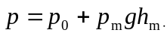 With the water to a depth 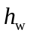, the gauge pressure at the bottom of the cylinder is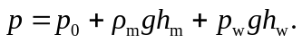 If this is to be double the first value, then 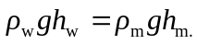
The volume of water is

